Koduri Keerthana
2400033253
ASSIGNED ENTITY : PRESCRIPTION
Entity: Prescription
Primary Key : prescriptionid : Long
Properties:
- name
- type
- status
- location
- createdAt
- updatedAt

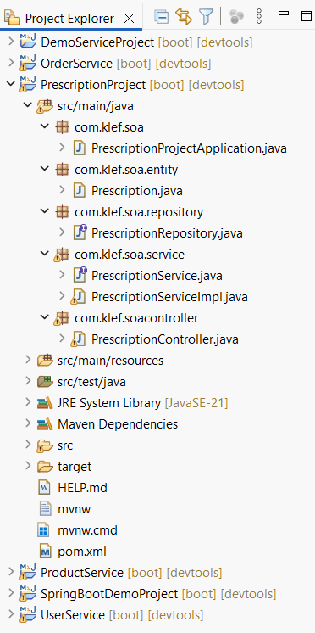
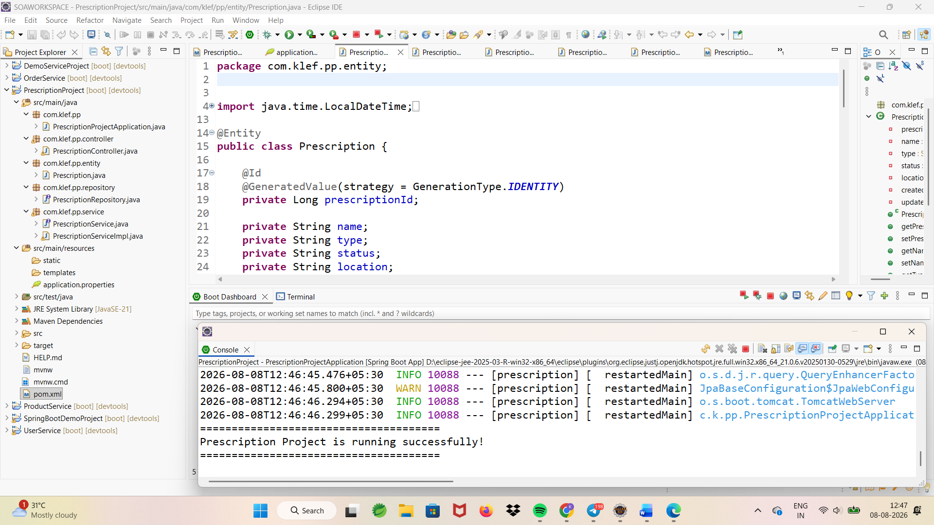
http://localhost:8080/swagger-ui/index.htmlwate
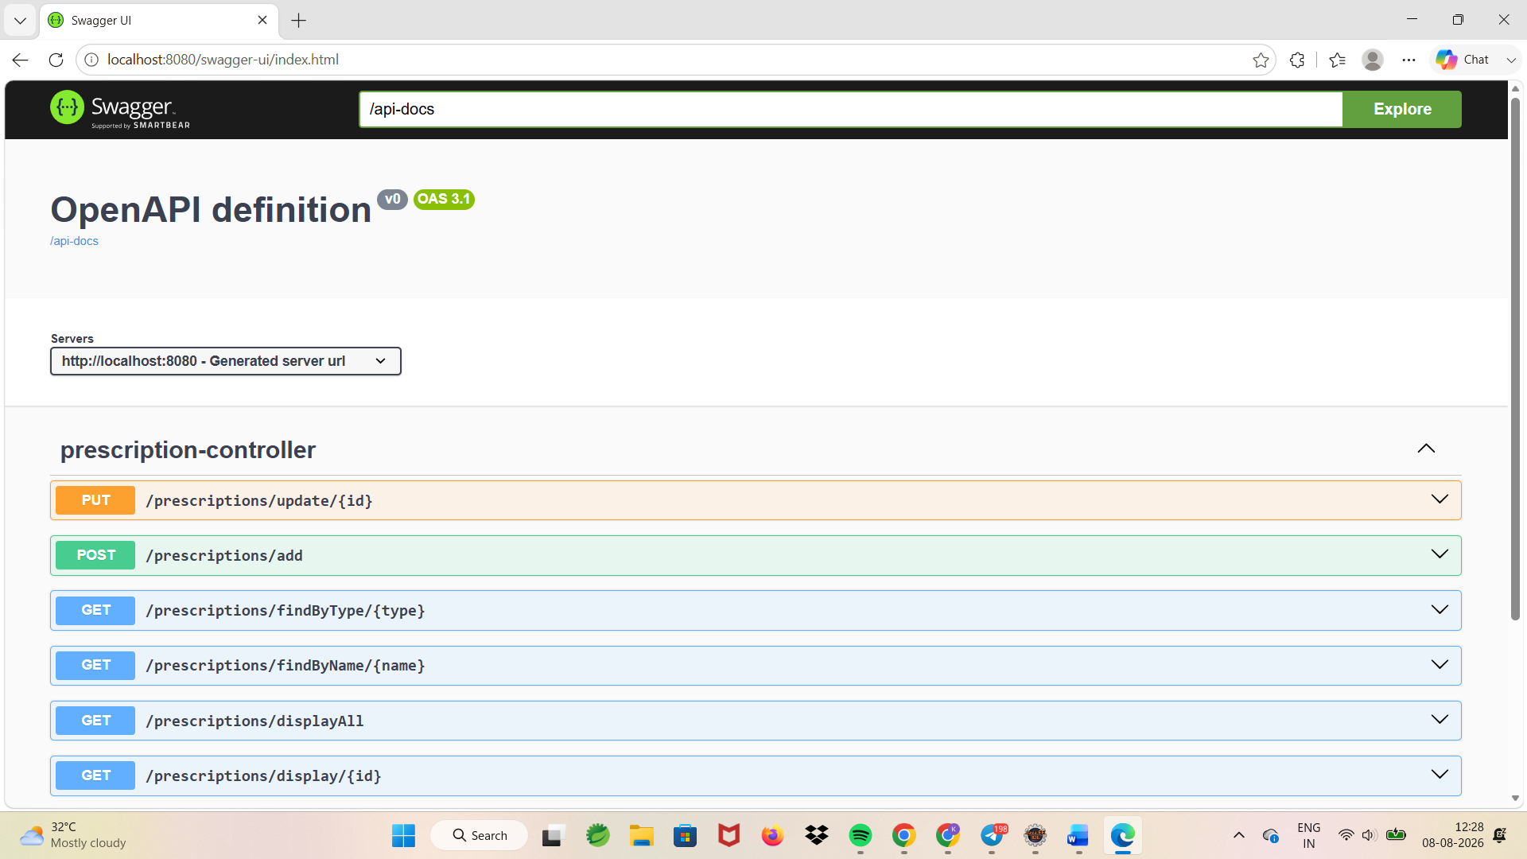

Insert operation
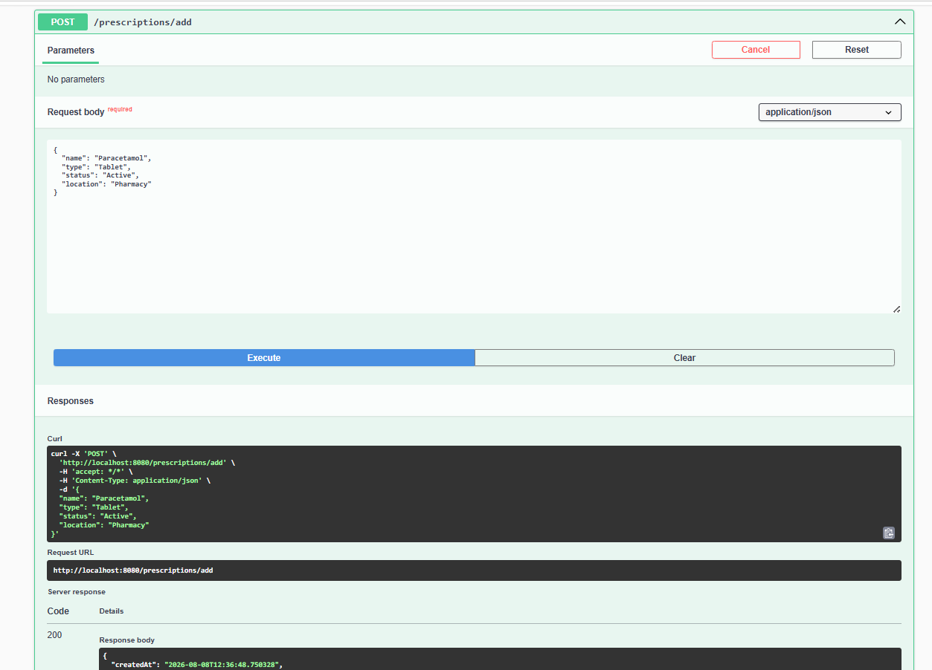
Display all
localhost:8080/prescriptions/displayAll
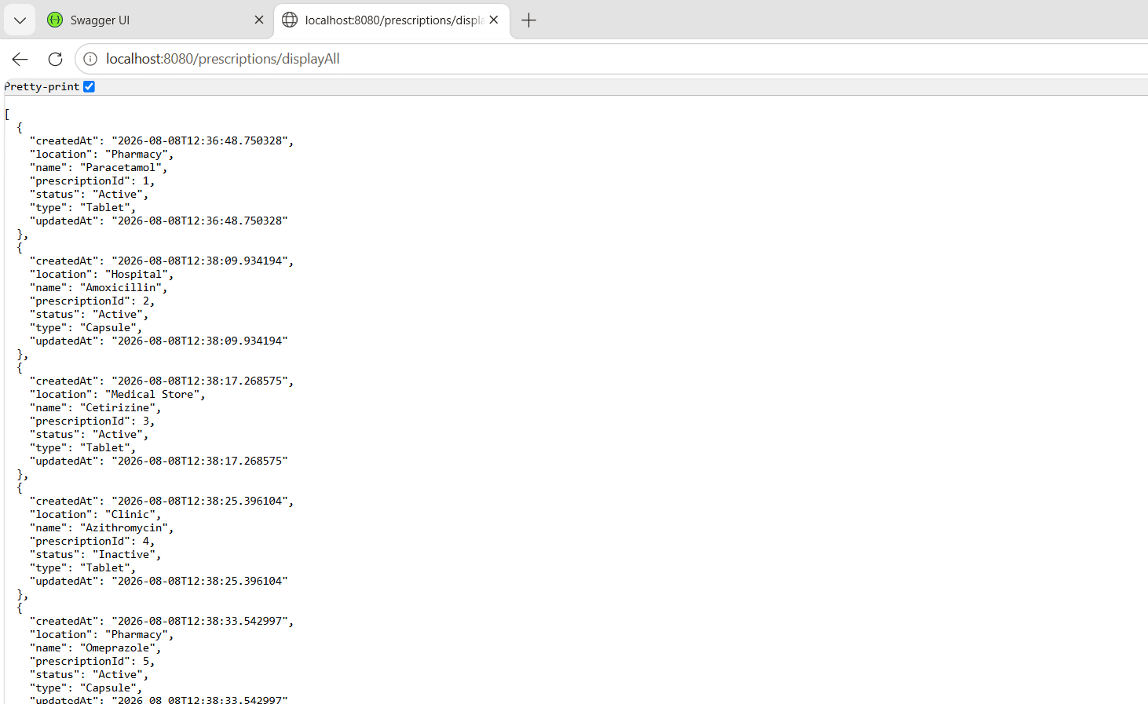

localhost:8080/prescriptions/display/1
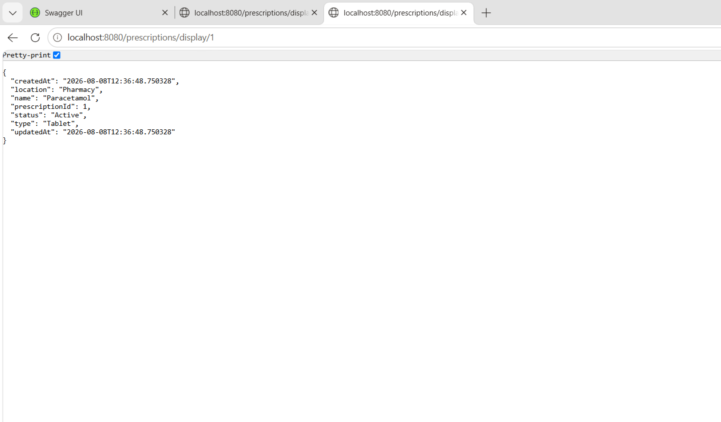
Update record by id
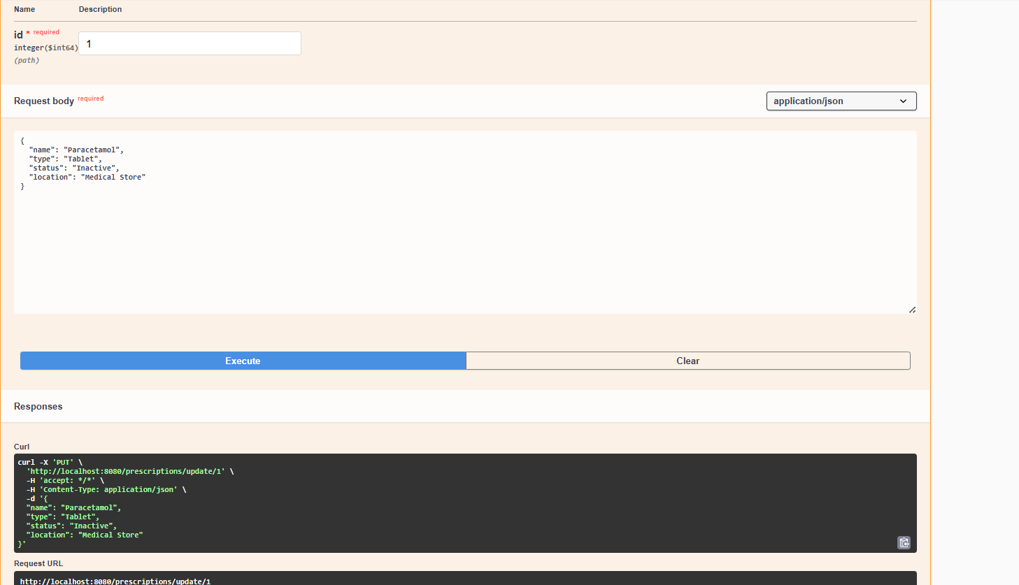
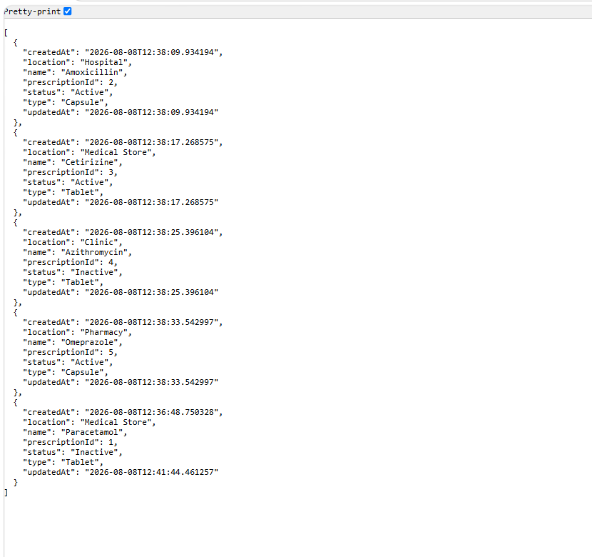

Delete by id
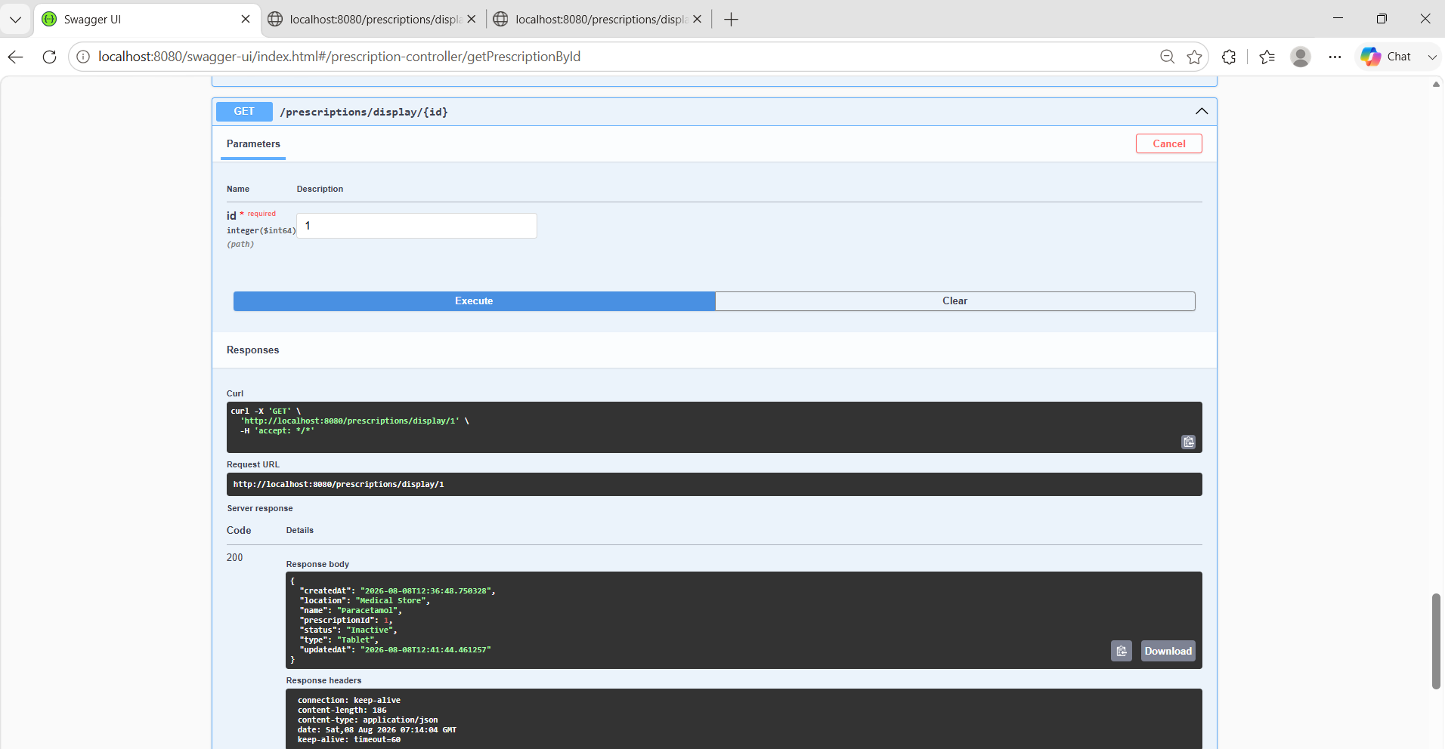
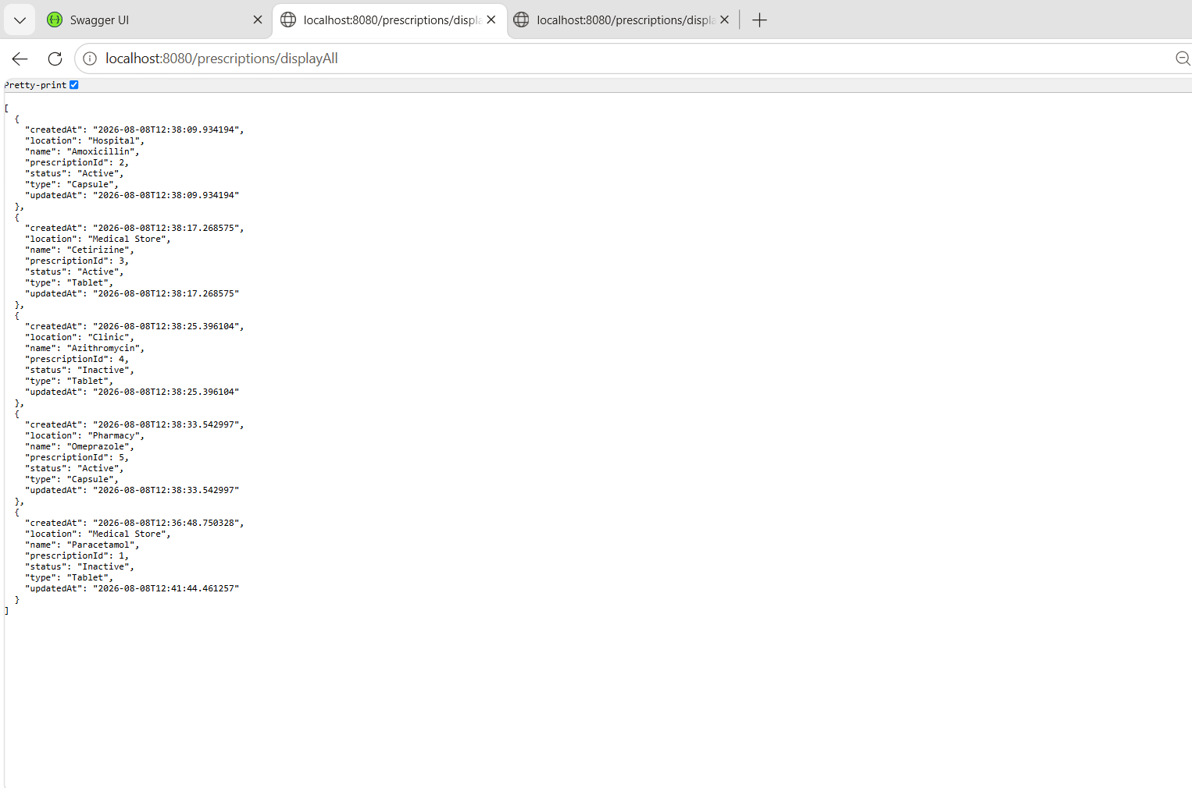

localhost:8080/prescriptions/findByName/Paracetamol
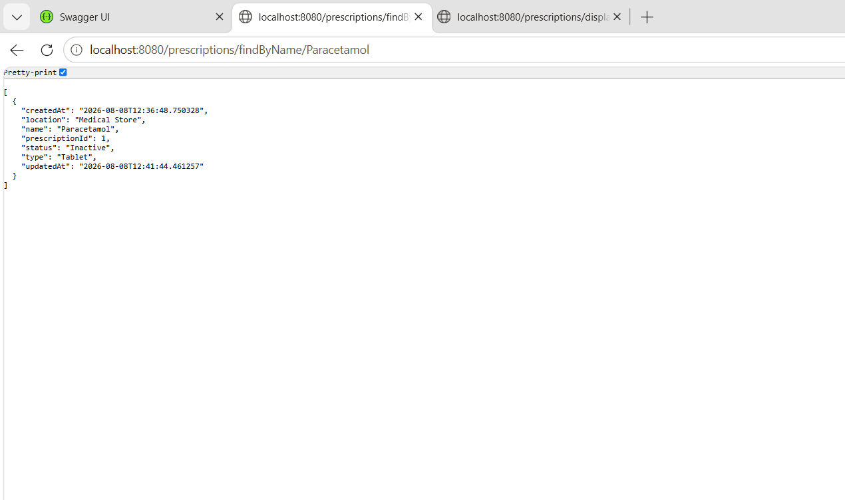
localhost:8080/prescriptions/findByType/Tablet
